ФИО (полностью) | Рожкова Елена, Солдатов Михаил, Ямчур Елена, 11 А класс  МБОУ Гимназия № 91, г.Железногорск Красноярского края
Руководитель | Казина Елена Павловна
Название статьи (полностью) | Motherland is calling! Родина-мать зовёт!
Язык | английский
Класс | 7-8
E-mail | mvsoldatov@yandex.ru
Методическая разработка «Символы победы», посвященная 75летию Победы

Many memorials were built in memory of the bravery of Russian soldiers in the Great Patriotic War in Russia. The greatest of them is placed in Volgograd.
Symbols of Victory

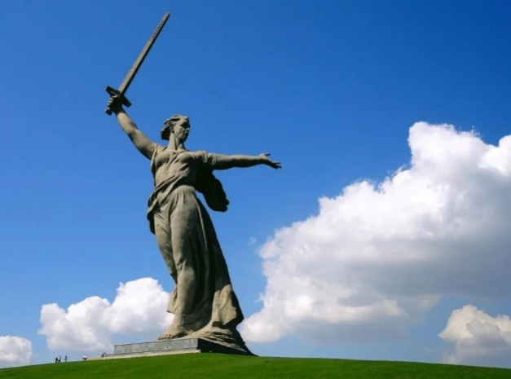
“Motherland is calling!”
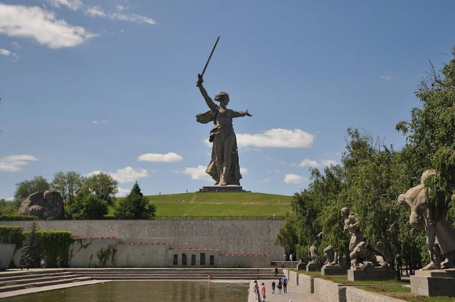
The biggest monument (85 m.) in Russia was built in 1967 in Volgograd on Mamayev Kurgan.
The work of sculptor Vuchetich and engineer Nikitin is a figure of a woman stepping forward in with a raised sword. Her shape is the motherland calling her sons to battle with the enemy. The monument was built in honor of the heroes who defended Stalingrad during the difficult years of the war. The sculpture of a woman is made of reinforced concrete. The total weight of the structure is more than 8000 tons.
The sculpture “Motherland is calling!” is famous all around the world. Therefore, in order to see this monument, not only Russians but also foreigners come to Volgograd. It can be seen both day and night because the sculpture is illuminated by searchlights
ACTIVITY
Tell the class about a hero city that you know.
DISCUSS
- Have you ever been to the monument “Motherland is calling!”? Describe your experience.
- What other interesting things about war would you like to see?

